HTML EXERCISES FOR PRACTICE IN LAB

Exercise:

1. Write HTML code to develop a web page having the background in red and title “My First Page” in any other color.



1. Create a HTML document giving details of your name, age, telephone, address, TLC code & enrollment no. aligned in proper order?

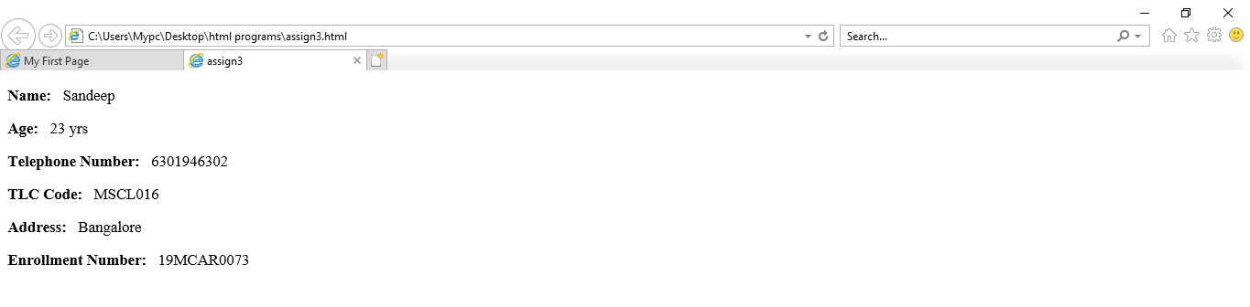

1. Write HTML code to design a page containing a text in a paragraph give suitable heading style.

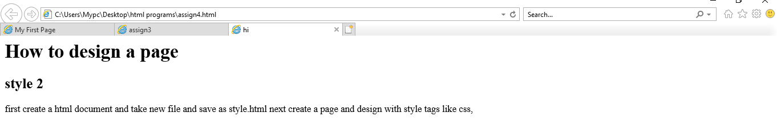

Session 2: Tags in HTML Exercise: